**Exemplar: Adding a data column using the IFS function**

**Overview**

In the exercise *Adding a Data Column Using the IFS Function*,you were asked to put into practice what you have learned about logical functions in Microsoft Excel.

Your task in this exercise was to create formulas to add new data columns and customized totals in the spreadsheet. The formulas had to:

* Create customized totals using the **SUMIF** formula.
* Use a logical function to test the order value and display the correct discount rate.
* Use an **IFS** function formula to populate a column with the correct regional delivery charge.

This reading provides you with a step-by-step guide for identifying these results. It also includes screenshots that you can compare against your own work.

You can review the formula creation techniques for this exercise in the videos *Using the IF function* and *Using the nested IF and IFS function*, and in the reading *AND and OR functions*.

**Step 1: Download the file**

* You downloaded and opened the Excel workbook *Contoso Bikes.xlsx***.**The workbook contained one worksheet called **Order Details** that includes details of the last order placed by Contoso Bikes. It includes information on the cost per stock unit and the number of items ordered.

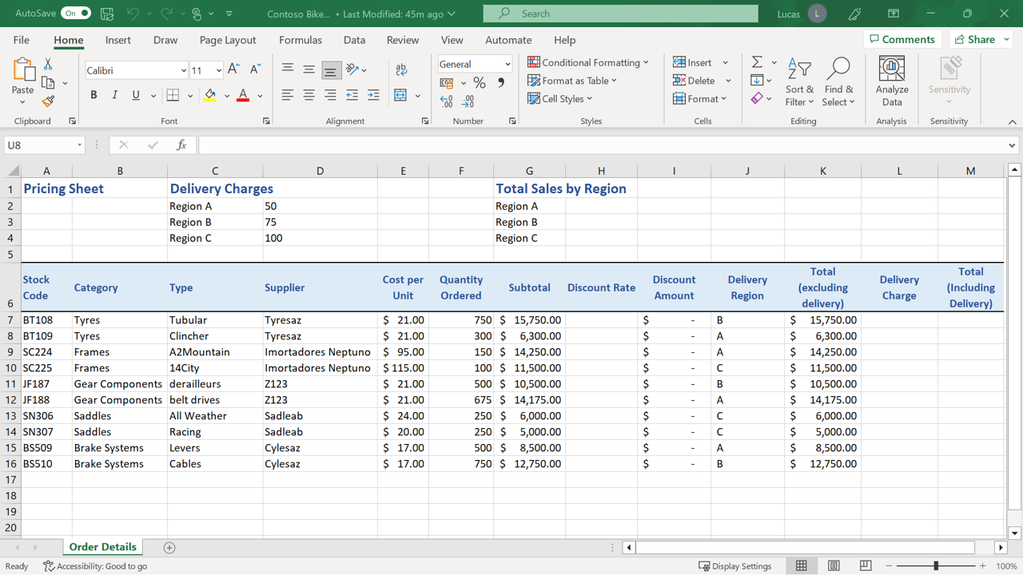

**Step 2: Creating the Calculations**

1. You had to use an **IF** function to create a formula in cell **H7**. The formula had to check the subtotal amount in column **G7**. If the amount was greater than $10,000, then the formula should display the result as 10%. If the amount was less than $10,000, the formula should display the result as 0.

The formula you created in **H7** should read:

**=IF(G7>10000,10%,0)**

The value in **G7** is $15,750, which is over the figure stipulated in the logical test. So, the **IF** formula returned the entry specified in the “value if true” section of the formula. The result generated in **H7** was 10%.

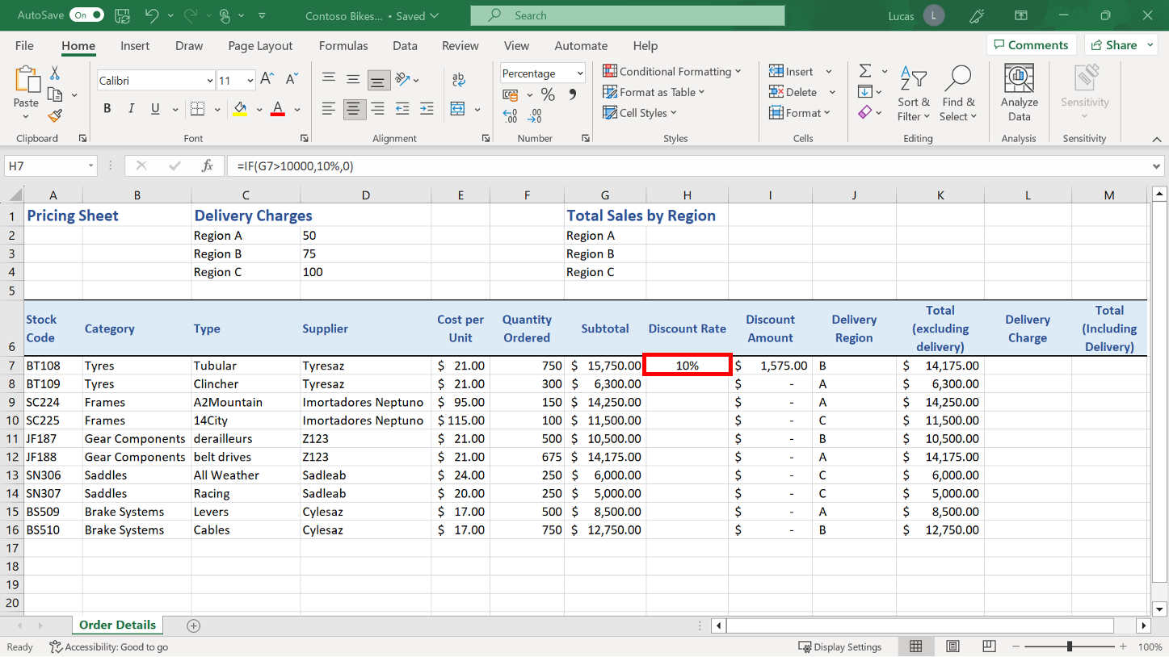

1. You were asked to create a formula in cell **L7** using the **IFS** function to work out the delivery charge applicable to each row. The formula needed to check the delivery region listed in **J7** and calculate the appropriate amount to charge.

The cost for delivery to each region was listed in the cell range **D2** to **D4**. If the delivery region was not A, B or C then the formula should return a value of 0. You also had to Include dollar signs to make the **D** references for the charges absolute.

There were three delivery regions listed in the cell range **D2** to **D4** and, as a result, the standard **IF** function was not appropriate here. This is because, by default, the **IF** function only performs one logical test. Instead, it was necessary to use the **IFS** function so that a series of two tests could be carried out to determine the correct delivery charge.

The formula created in **L7** should read:

**=IFS(J7=”A”,$D$2,J7=”B”,$D$3,J7=”C”,$D$4,True,0)**

The formula runs a series of “if this true, do this” tests. Finally, if all tests fail, it should display a value of 0.

The three references **D2**,**D3** and **D4** required dollar signs so that they stayed constant when the formula is copied down column **L**.

The **J7** reference does not need these signs as that reference must update row-on-row as the formula was copied down the column.

The A, B, and C letters that the formula is checking for need double quotes on either side to alert Excel that it is checking for text characters.

The result in **L7** should be $75, which is the delivery charge for Region B.

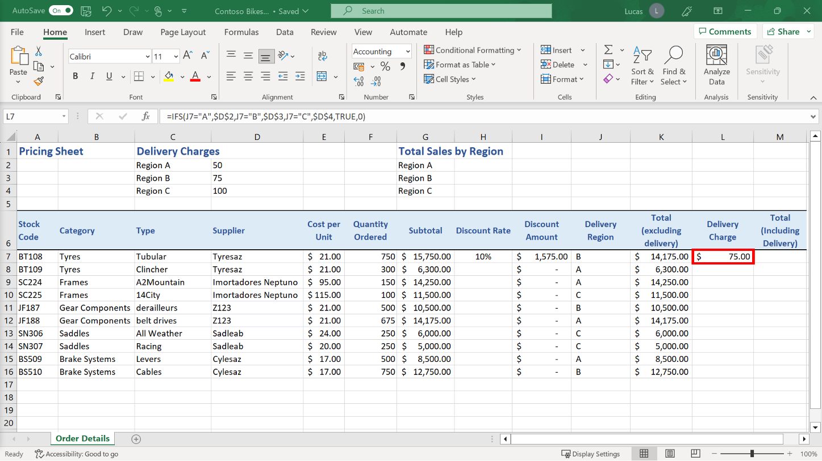

1. You had to create a formula in cell **M7** to add together the total (excluding the delivery amount) in **K7** and the delivery charge in **L7**.

The formula in **M7** is an addition formula. It should read:

**=K7+L7**

The result should be $14,250.00.

1. Next you had to **Autofill** to copy the formula in **H7**, **L7** and **M7** down to row **16**. Because there was a block of data to the left of the formula in **H7** you could have used the double-click method to copy the formula down as far as row 16. The formulas in **G7** and **I7** are both multiplication formulas, so Excel flags the entry in **H7** as an inconsistent formula.

It does this by adding a green triangle to the left of each cell that the formula has been copied into. When you hover the mouse pointer over the green triangle on the first entry, a yellow warning symbol appears.

Selecting this triangle opened a drop-down menu. This menu included the choice **Ignore Error.** This option was correct in this instance, as the different formula in column **H** was deliberate and not the result of a mistake.

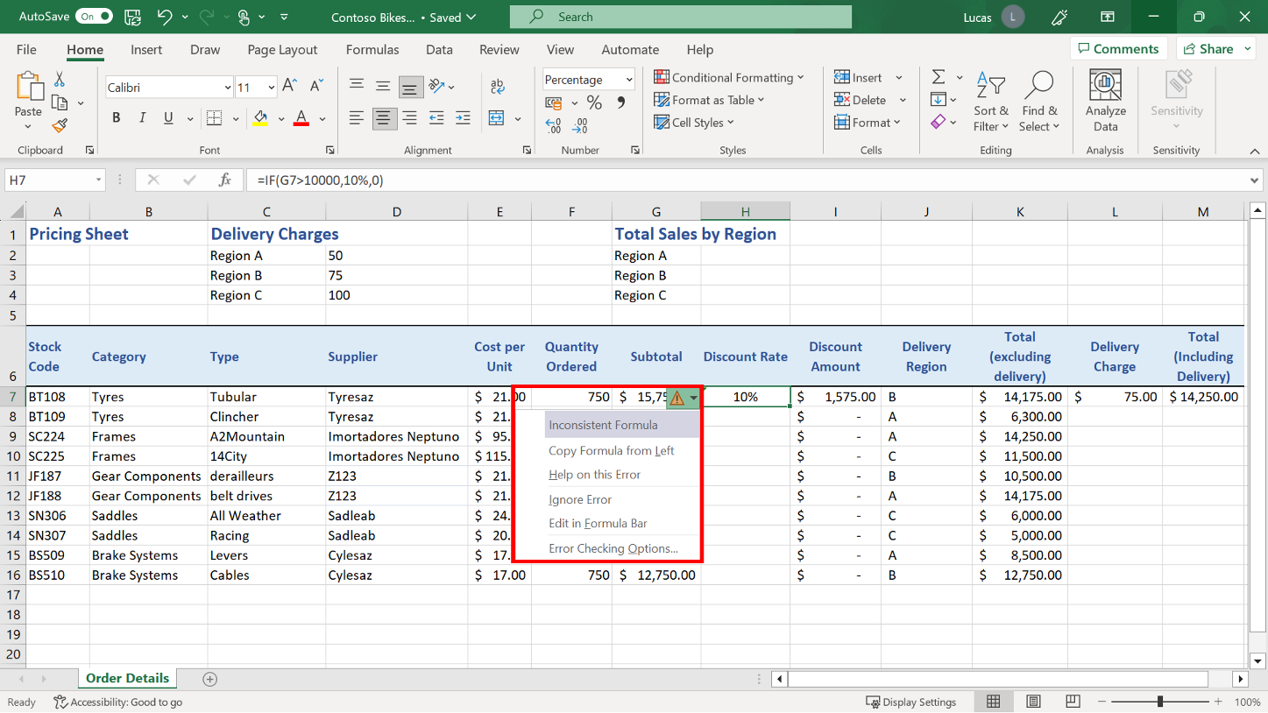

1. You were asked to create a **SUMIF** formula in cell **H2** that calculated a sales Total (excluding delivery) for Region A.  The **SUMIF** formula in **H2** uses the cell range **J7** to **J16** as the first argument. This block of cells is where the formula checks for the criteria.

The cell range **K7** to **K16** is the sum range. This is the block of cells where Excel selects the specific numbers to include in the total. These would be on any row where Excel has identified the criteria in column **J**.

The formula in **H2** should read:

**=SUMIF(J7:J16,”A”,K7:K16)**

The result of this formula is $40,382.50

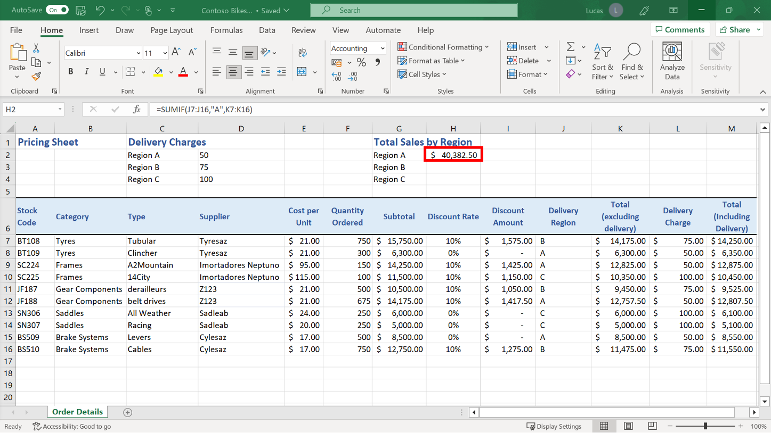

1. Next, you had to create a **SUMIF** formula in cell **H3** that calculated a sales total (excluding delivery) for Region B.

The formula created in **H3** should read:

**=SUMIF(J7:J16,”B”,K7:K16)**

The result of this formula should be $35,100.00.

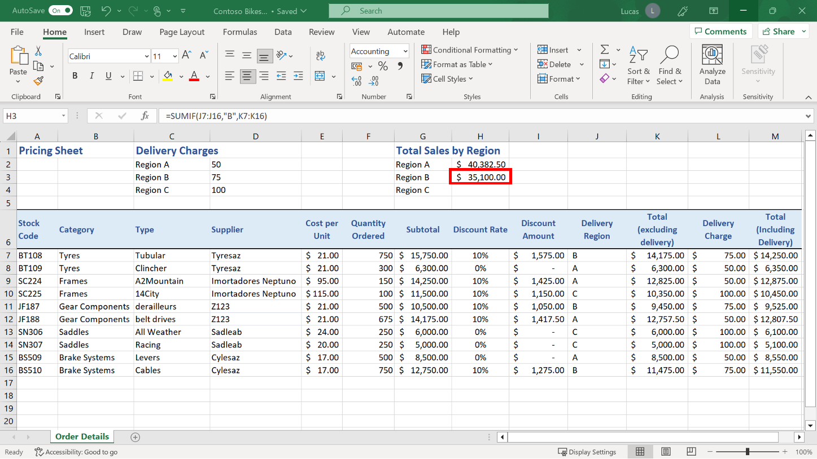

1. You created a **SUMIF** formula in cell **H4** to calculate a sales total (excluding delivery) for Region C.

The formula created in **H4** should read:

**=SUMIF(J7:J16,”C”,K7:K16)**

The result of this formula should be $21,350.00.

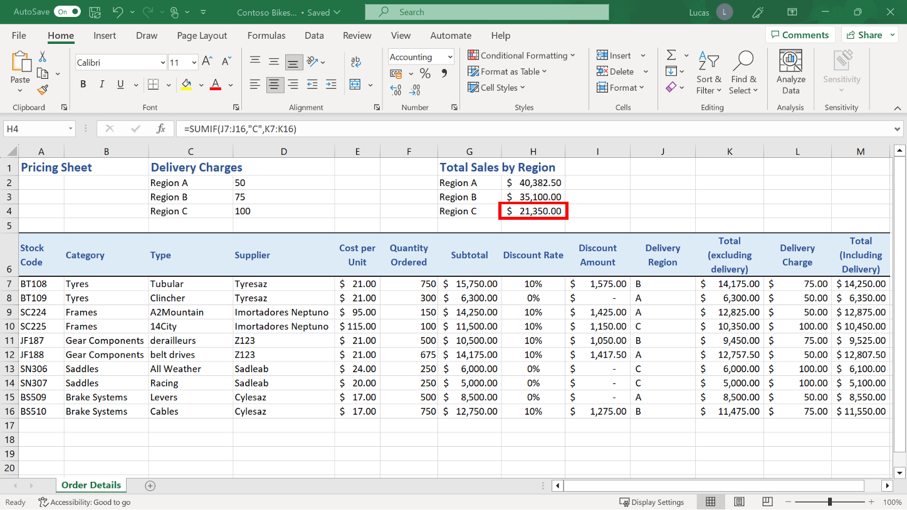

**Conclusion**

In this exercise, you were tasked with using a range of logical function formulas to create data columns in a spreadsheet and calculate customized totals.

You should now be more familiar with the available logical function formulas, their syntax, and their use.